**Ganpat University**

**Faculty of Engineering & Technology**

**Computer Science & Engineering**

**Practical_1**

***Name:- Dwij Vatsal Desai***

***Sem:- 3***

***Sub: - DS(Data Steucture)***

***Enrollment No.:- 23162121027***

**1.** Gross Salary Problem In a company an employee is paid as under: Along with the basic salary, the employee would be given dearness allowance of 40% of his basic salary and house rent allowance of 20% of his basic salary. If the basic salary of an employee is received as input, write a program to find his/her gross salary.

Input:

Take basic Salary as input Output:

Output the gross salary.

Example

Input:

1203

Output:

1924.800049

Code:

*#include* <stdio.h>

int main(){

    float inSalary;

    printf("Enter the your Salary Here:\t");

    scanf("%f",&inSalary);

    float Salary_20 = (inSalary*0.2);

    float Salary_40 = (inSalary*0.4);

    float TSalary = ((Salary_40+ Salary_20)+ inSalary);

    printf("Output as total of the orignal Salary is:\t %f",TSalary);

*return* 0;

}

Image:

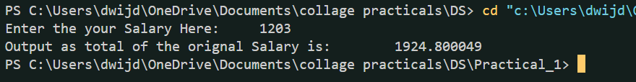

**2.** Conversion Problem

The distance between two cities (in km.) would be given by the user. Write a program to convert

and print this distance in:

1. Feet.

2. Meters.

3. Inches.

4. Centimeters.

Input:

The input for the code would contain the distance between two cities in kilometers. Output: The distance in each of the mentioned units.

Example:

Input: 50

Output:

Feet: 164042.000000

Meters: 50000.000000

Inches: 1968505.000000

Centimeters: 500000.000000

Code:

*#include* <stdio.h>

int main(){

    float km=0;

    printf("Enter your unit in Km:\t");

    scanf("%f",&km);

    float feet = (km* 3280.84);

    float meter = (km* 1000);

    float inche = (km* 39370.08);

    float cm = (km* 100000);

    printf("\nFeet: %f\n",feet);

    printf("meter: %f\n",meter);

    printf("inche: %f\n",inche);

    printf("cm: %f\n",cm);

*return* 0;

}

Image:

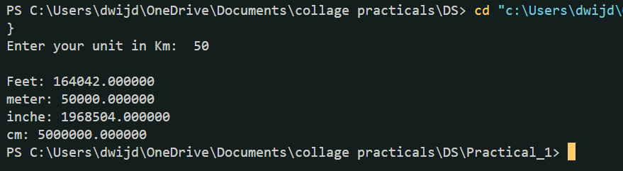

**3.** Marks Calculator

A student enters his/her marks of 5 subjects in a program.

Assume that the maximum marks that can be obtained by a student in each subject to be 100. Write a program to calculate the aggregate marks of the student. Also, calculate the percentage marks obtained by the student.

Input:

Marks of 5 Subjects separated by spaces. Output:

Aggregate Marks on the first line. Percentage on the second line.

Example:

Input:

60 76 88 68 90

Output:

Total: 382

Percentage: 76.400002

Code:

*#include* <stdio.h>

int main(){

    int s1,s2,s3,s4,s5;

    printf("Enter the 5 Subjects separated below:\n");

    scanf("%d %d %d %d %d",&s1,&s2,&s3,&s4,&s5);

    int total = s1+s2+s3+s4+s5;

    float persentage = (total/500.0)*100;

*if*(s1<=100&& s2<=100&& s3<=100&& s4<=100&& s5<=100){

        printf("\nTotal:\t%d",total);

        printf("\nPersentage:\t%f",persentage);

    }*else*{

        printf("Enter the corrat value of 5 Subjects");

    }

*return* 0;

}

Image:

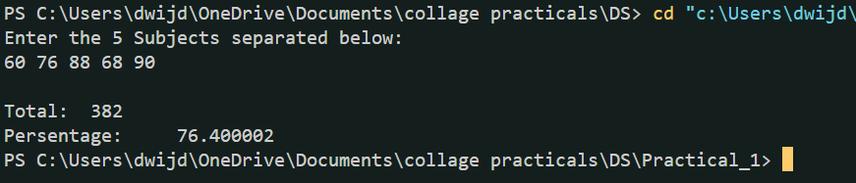

**4.** Sum of Digits

The user will enter a four-digit number.

Write a program that calculates the sum of its digits. (Hint: Use the modulus operator ‘%’).

Input:

Four-digit number.

Output:

Sum of the four digits.

Example

Input: 1234

Output:

10

Code:

*#include* <stdio.h>

int main(){

    int Digi4=0,digi[4];

    printf("Enter the four-digit number:\t");

    scanf("%d",&Digi4);

*if* (Digi4<=9999 && Digi4>=1000)

    {

*for*(int i=0; i<4; i++){

            digi[i] = Digi4%10;

            Digi4=Digi4/10;

        }

        printf("Total of 4 digit:\t%d",(digi[0]+digi[1]+digi[2]+digi[3]));

    }*else*{

        printf("\n\nERROR:Entered number is not four-digit long");

    }

*return* 0;

}

Image:

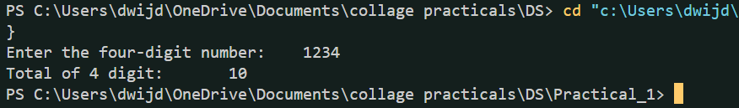

**5.** Decrementing Digit Problem

Suppose a five-digit number is input by a user.

Write a program to print a new number by subtracting one to each of its digits. For example if the number that is input is 12391 then the output should be displayed as 01280.

Input:

Five-digit Number. (12391) Output:

Number with each entry of digit decremented by 1. 1 -&gt; 0

2 -> 1

3 -> 2

9 -> 8

1 -> 0

Example:

Input: 12391

Output: 01280

Code:

*#include* <stdio.h>

int main(){

    int Digi5=0,digi[5];

    printf("Enter the five-digit number:\t");

    scanf("%d",&Digi5);

*if* (Digi5 >= 10000 && Digi5<=99999)

    {

*for* (int i = 0; i < 5; i++) {

            digi[4- i] = Digi5 % 10;

            Digi5 /= 10;

            digi[4- i] = --digi[4- i];

        }

        printf("Digits: ");

*for* (int i = 0; i < 5; i++) {

            printf("%d", digi[i]);

        }

        printf("\n");

    }*else*{

        printf("\n\nERROR:Entered number is not four-digit long");

    }

*return* 0;

}

Image:

